A.V.KAVERI ,
192512188.
Experiment No: 7
Title: Simulation of a Smart City Traffic Management System Using Python (Google Colab)
Aim
To develop and simulate a Smart City Traffic Management System using Python in Google Colab that dynamically controls traffic lights based on vehicle density, clears cars from the busiest lane, and visualizes traffic flow through real-time graphs.
Objective
The objective of this experiment is to simulate a density-based traffic light controller for a smart city. The system continuously monitors the number of vehicles waiting at four lanes (North, South, East, West). At each traffic cycle, new cars arrive randomly, and the lane with the highest density is given a green light. Cars are cleared from that lane, while others remain on red. The simulation updates a live bar graph showing the number of cars in each lane, with the active lane highlighted in green. This experiment demonstrates how dynamic traffic control can reduce congestion and improve efficiency in smart city environments.
Software Requirements
- Google Colab
- Python 3.x
Python Libraries Used
- random
- matplotlib
- IPython.display
- time
Theory
Traditional traffic lights operate on fixed timers, which may cause congestion when vehicle density varies across lanes. A smart traffic management system uses dynamic control, where the busiest lane is prioritized with a green signal. This reduces waiting time and improves traffic flow efficiency.
In this simulation, vehicle arrivals are generated randomly, and the system identifies the lane with the maximum queue. Cars are cleared from that lane, and the updated traffic status is displayed in a bar graph. The green bar indicates the active lane, while red bars represent waiting lanes. This demonstrates how density-based traffic control can be implemented using Python simulation.
Algorithm
- Start the program.
- Import required Python libraries.
- Define lane names (North, South, East, West).
- Initialize car queues for each lane.
- Set the number of traffic cycles.
- For each cycle:
  - Generate random new cars for each lane.
  - Update lane queues.
  - Identify the busiest lane.
  - Clear cars from the busiest lane.
  - Display updated traffic graph with active lane in green.
  - Show cleared car count.
  - Wait before next cycle.
- Repeat until all cycles are completed.
- Display completion message.
- Stop the program.
Flowchart
Code
START
│
▼
Import Required Libraries
│
▼
Initialize Traffic Lanes & Queues
│
▼
Set Simulation Steps
│
▼
Generate Random New Cars
│
▼
Update Lane Queues
│
▼
Identify Lane with Maximum Cars
│
▼
Clear Cars from Active Lane
│
▼
Display Updated Traffic Graph
│
▼
Wait Before Next Cycle
│
▼
More Cycles Remaining?
│ │
Yes No
│ │
▼ ▼
Generate Next Display Final
Traffic Cycle Summary
│
└──────────────►
▼
END
Program Description
The Python program simulates traffic flow at a four-way junction. Each cycle, random cars arrive at each lane, and the lane with the maximum queue is given a green light. Cars are cleared from that lane, and the updated traffic status is displayed in a bar graph. The simulation continues for 20 cycles, showing dynamic traffic control in action.
Input
- Lane names: North, South, East, West
- Initial car queues
- Number of simulation cycles
- Randomly generated new cars per cycle
Output
- Live bar graph showing cars in each lane
- Green bar for active lane, red bars for waiting lanes
- Text showing number of cars cleared per cycle
- Final completion message
Observations
- Vehicle queues increase randomly each cycle.
- The busiest lane is always prioritized with a green light.
- Cars are cleared dynamically, reducing congestion.
- Graphs update in real time with lane status.
Applications
- Smart city traffic management
- Intelligent transportation systems
- IoT-based traffic monitoring
- Urban congestion control
- Simulation for traffic engineering research
Advantages
- Dynamic traffic control based on density
- Real-time visualization of traffic flow
- Reduces congestion at busy lanes
- Easy to implement and extend
- Cost-effective simulation without sensors
Limitations
- Uses simulated traffic data
- No real sensors or IoT devices connected
- Limited to four lanes in this experiment
- Suitable only for academic demonstration
Result
The Smart City Traffic Management System was successfully simulated using Python in Google Colab. The system dynamically controlled traffic lights based on lane density, cleared cars from the busiest lane, and displayed real-time traffic flow through graphs. Thus, the experiment demonstrated effective congestion management using density-based traffic control in a simulated smart city environment.
OUTPUT:
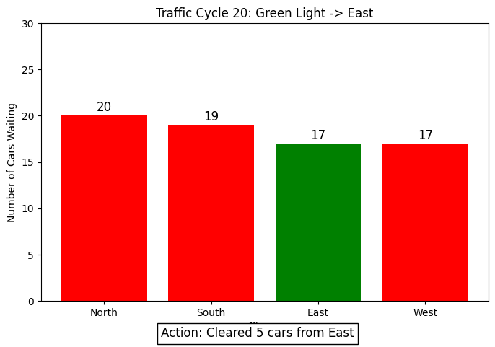
Simulation Completed Successfully!

